

**ATAR HUMAN BIOLOGY – UNIT 1**

**TASK 6 – Digestive, Excretory & Musculoskeletal systems test**

**NAME: _________________________________ WEIGHTING: 5%**

**MARK: ______ / = _____ %**

**Answers**

Important Information for Students

1. There are THREE sections in this test - Multiple Choice, Short Answer and Extended Answer.
2. This is a closed-book assessment (no notes are allowed)
3. The time allowed to complete the test is 55 minutes.
4. Write your answers to the Multiple Choice section on the **separate** answer sheet provided.
5. Write your answers to the Short Answer section in space provided.
6. Write your answers to the Extended Answer section in space provided.

|  |  |  |
| --- | --- | --- |
| Sections | **Marks Allocation** | **Your Total** |
| **A - Multiple Choice** | 10 |  |
| **B - Short Answer** | 34 |  |
| **C - Extended Answer** | 6 |  |
| **TOTAL** | 50 |  |

1. A B C D 6. A B C D

2. A B C D 7. A B C D

3. A B C D 8. A B C D

4. A B C D 9. A B C D

5. A B C D 10. A B C D

**Multi Choice Section (10 Marks)**

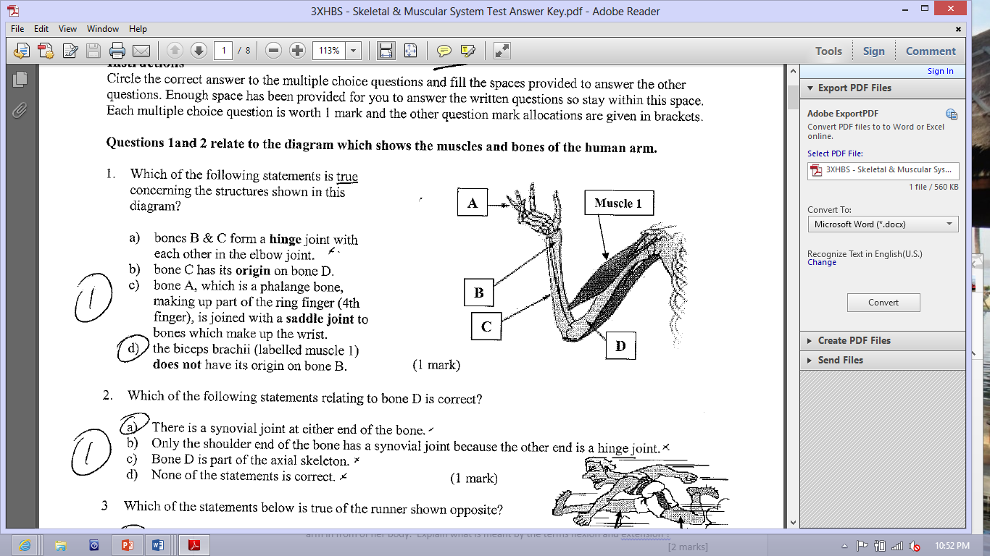

1. Which of the following statement is true concerning the structures shown in this diagram ?
2. Bones B & C form a hinge joint with each other in the elbow joint
3. Bone C has its origin on bone D
4. Bone A, which is a phalange bone, making up part of the ring finger) is joined with a saddle joint to bones which make up the wrist
5. The biceps (labelled muscle 1) does not have its origin on bone B
6. 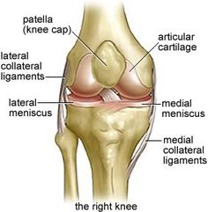A common sports injury suffered by sportsmen is the rupturing of the cruciate ligament in a knee joint. In the diagram, the posterior cruciate ligament (PCL) has been torn and the knee will need to be reconstructed. In this diagram, several structures have been labelled A, B, C and D. Which of the following statements is correct?

C

A

B

1. Structure C is cartilage

D

1. Structure A between C and D is a bursa
2. Structure C is a ligament as it holds B and D together
3. B and D from a pivot joint
4. Which of the following is not an example of a synovial joint?

a. The knee.

b. The cranium.

c. The thumb and palm.

d. The elbow.

Question 4 refers to the diagram of the functional unit of skeletal muscle shown below



1. During muscle contraction:
2. structure C decreases in length.
3. the distance represented by A lengthens.
4. structure D increases in length.
5. the distance represented by B shortens.
6. A bursa is:

a. part of a bone

b. part of the pelvis

c. a sac of fluid often found between tendons and bone

d. connective tissue found in muscles.

1. Which of the following describes the direction of blood flow through the kidney?
2. renal artery, renal vein, afferent arteriole, efferent arteriole, peritubular capillaries.
3. renal vein, renal artery, afferent arteriole, efferent arteriole, peritubular capillaries.
4. renal artery, efferent arteriole, afferent arteriole, peritubular capillaries, renal vein.
5. renal artery, afferent arteriole, efferent arteriole, peritubular capillaries, renal vein.

The table below shows the normal % composition of some components of blood plasma, fluid in the Bowman’s capsule and urine.

|  |  |  |  |
| --- | --- | --- | --- |
| **Component** | **Blood plasma** | **Bowman’s capsule** | **Urine** |
| **Urea** | 0.03 | 0.03 | 2.00 |
| **Uric acid** | 0.004 | 0.004 | 0.05 |
| **Glucose** | 0.10 | 0.10 | None |
| **Amino acids** | 0.05 | 0.05 | None |
| **Minerals** | 0.72 | 0.72 | 1.50 |
| **Proteins** | 8.00 | none | none |

1. Why is there a large amount of protein found in the blood but none in the capsule or urine?
2. The proteins are converted to amino acids before they enter the capsule.
3. The proteins are too large to move through the capsule membrane.
4. The proteins are needed by the body and so are not filtered.
5. The proteins are converted by the capsule into amino acids.
6. Which of the following is NOT a function of saliva?
7. Initial digestion of proteins.
8. Lubrication of the mouth.
9. Initial digestion of carbohydrates.
10. Lubrication of food.
11. Deamination is a metabolic process that involves:
12. carbohydrates under the influence of insulin.
13. fats in the kidney.
14. proteins in the liver.
15. vitamins in the adrenal medulla.
16. What is the role of the kidney in the excretory system of mammals?
17. To remove nitrogenous waste from the body and maintain water levels in the body
18. To remove salt from the body and to keep water in the body
19. To remove water from the body and keep salt in the body
20. To remove water from the body and maintain levels of nitrogenous substances in the body.

**Short Answer Section (34 marks)**

1. [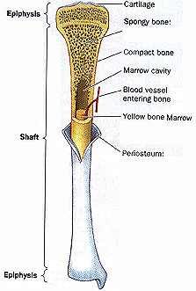](http://www.physioweb.org/skeletal/bone_tissue.html)
2. Describe two major differences between the spongy bone and the compact bone. *(2 marks)*

|  |  |
| --- | --- |
| **Description** | **Marks** |
| Spongy made of trabeculae/random bone cell arrangement, compact osteons/cylinder arrangement | 1 |
| Spongy found at ends of bone/epiphysis, compact mainly in the diaphysis | 1 |
|  | **Total** 2 |

1. Explain why the average age of any bone in an adult is no more than 10 years old. (*2 marks)*

|  |  |
| --- | --- |
| **Description** | **Marks** |
| Bones is continually being broken down and rebuilt | 1 |
| Process means all the bone is roughly remade every 10 years regardless of age | 1 |
|  | **Total** 2 |

1. (a) Name the three types of muscle that can be found in the body. *(1 mark)*

Smooth/involuntary, skeletal/voluntary/striated, cardiac

(b) Draw and label a diagram to show the structures found inside a muscle.  *(3 marks)*

½ mark per label

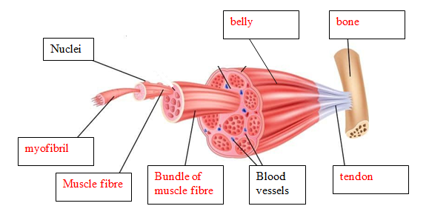

1. Describe the functions of ligaments. *(1 mark)*

Connect bone to bone/hold joints together

1. Vertebrae in the human body are joined by cartilaginous joints.
2. Name the type of cartilage that joins vertebrae to each other. *(1 mark)*

Fibrocartilage/

1. Describe how the structure of cartilage referred to in part (i) suits its function. *(2 marks)*

|  |  |
| --- | --- |
| **Description** | **Marks** |
| Fibro cartilage made of thick fibres/coarse | 1 |
| Gaps between fibres enable the cartilage to be squashed slightly so spine can bend | 1 |
|  | **Total** 2 |

1. Complete the table below, summarising chemical digestion in the alimentary canal. *(3 marks*)

|  |  |  |  |
| --- | --- | --- | --- |
| **Dietary Nutrient** | **Enzyme** | **Nutrient to be absorbed** | **What part/s of the alimentary canal does this chemical digestion occur in?** |
| Carbohydrate | Amylase | Simple sugar/glucose/monosaccaride | Mouth, duodenum |
| *Fat* | Lipase | Fatty acids & glycerol | Duodenum |

1/2 mark for each correct answer

1. Enzymes are added in the mouth to break down food. The same enzyme then has to be added again once the food has passed through the stomach. Explain, in detail, why this is necessary. *(3 marks)*

|  |  |
| --- | --- |
| **Description** | **Marks** |
| Enzyme will only partially break down the substrate/carbohydrate | 1 |
| Once enters the stomach enzymes denatured by acid | 1 |
| Need to add more amylase to finish of the breakdown of the substrate/carbohydrate | 1 |
|  | **Total** 3 |

1. Explain why mechanical digestion is a vital part of the digestion process? *(2 marks)*

|  |  |
| --- | --- |
| **Description** | **Marks** |
| Mechanical digestion increases the surface area of the food to be broken down | 1 |
| Therefore the enzyme can be more effective/any suitable word, at breaking the food down | 1 |
|  | **Total** 2 |

1. Cystic Fibrosis is a genetic condition that results in the person producing excessive amounts of mucus. This thick, sticky mucus accumulates on the mucus linings of the digestive.

Explain how this condition would affect the functioning of the small intestine and consequently the health of the Cystic Fibrosis sufferer. *(3 marks)*

|  |  |
| --- | --- |
| **Description** | **Marks** |
| Villi/microvilli covered in thick mucus making distance from food to blood vessel greater | 1 |
| Reabsorption of nutrients would be difficult/slow/little would pass through | 1 |
| Little nutrients absorbed so person deficient in vitamins & minerals/not enough glucose for energy/not enough amino acids to make proteins/any suitable connection to health | 1 |
|  | **Total** 3 |

1. (a) Name two organs in the body that take part in excretion besides the liver and the kidney.

*(2 marks)*

*Lungs (1 mark) Skin (1 mark) large intestine/rectum (1 mark)*

(b) Refer to the diagram below of the kidney nephron and associated blood vessels.

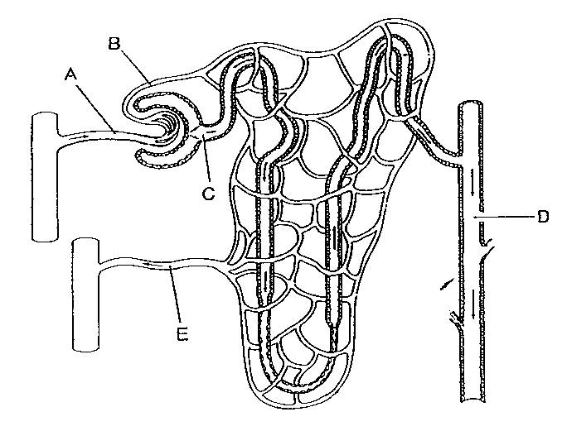

Outline three reasons why the nephron is suited to its function. *(3 marks)*

|  |  |
| --- | --- |
| **Description** | **Marks** |
| It is very long/convoluted, so large SA:Vol – maximise reabsorption in small space  Bowmans capsule completely surrounds glomerulus so all filtrate can be collected  One cell thick so nutrients can easily diffuse out  Filtrate/blood in glomerulus continually moving so gradient maintained | 1 - 3 |
|  | **Total** 3 |

(c) Where do tubular secretions take place in the nephron and explain their purpose? *(2 marks)*

|  |  |
| --- | --- |
| **Description** | **Marks** |
| Place : Distal convoluted tubule | 1 |
| Purpose : hydrogen ions removed to balance pH of blood  Ammonia removed as toxic to body  Creatinine removed as toxic to body  Potassium removed to help with water balance  Urea removed as waste product and not needed/toxic | 1 - 2 |
|  | **Total** 3 |

(d) Whilst at the doctor, Bob had his urine tested and it was found that he had high amounts of protein present in his urine sample. Explain why the doctor would be concerned about Bob’s health after reading this information. *(2 marks)*

|  |  |
| --- | --- |
| **Description** | **Marks** |
| Protein is too big to diffuse into filtrate/glomerulus | 1 |
| Indicates kidney failure/kidney disease/ damage to glomerulus / damage to Bowman’s capsule | 1 |
|  | **Total** 2 |

1. Urea is a toxic waste product that is produced by normal processes in the human body. Explain how urea comes to be present in the body *(2 marks)*

|  |  |
| --- | --- |
| **Description** | **Marks** |
| Liver breaks down proteins – turns to amino acids | 1-2 |
| Deamination produces ammonia |
| The ammonia is toxic/dangerous if left to build up |
| Ammonia converted to urea |
|  | **Total** |

**Extended Response Question (6 marks)**

1. After eating a piece of steak, the body carries out a series of processes to break the protein down. Explain in detail the process of digesting the protein.

|  |  |
| --- | --- |
| **Description** | **Marks** |
| In the mouth the protein is mechanically broken down by the teeth | 1-6 |
| In the stomach – mechanical digestion by churning |
| In the stomach pepsin/gastric protease starts the breakdown of protein |
| Acid is needed for the pepsin to work |
| Chyme sent to the duodenum where bile neutralises it |
| Protease is added to duodenum from the pancreas |
| Protease is added from intestines to the duodenum |
| Protein is broken down into amino acids |
|  | **Total** 6 |